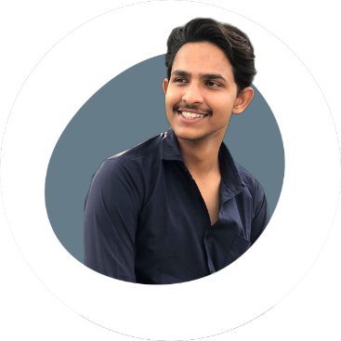**RESUME**

**PROFILE**

As a dedicated computer science student pursuing a B.Tech. degree (till 2025).

I have cultivated a strong foundation in C, C++, HTML, CSS, and JavaScript,

Complemented by my proficiency in Data Structures & Algorithms. I am also

well-versed in Full Stack Web Development.

**EDUCATION**

Pratham

Choudhary

* + - * + Highschool from Greater Noida World School in 2019 with IST division.
        + Interschool from Greater Noida World School in 2021 with IST division.
        + Currently doing B.Tech. from KCC Institute of Technology and Management in Greater Noida and will be completed till 2025.

**COURSES**

* Data Structure, Algorithm & Full Stack Web Development from Diginique Techlabs. [**Click here**](https://cards-by-pc.netlify.app/)

**MAY 2022 – APRIL 2023**

* C certification course from Sololearn. [**Click here**](https://cards-by-pc.netlify.app/)

**JULY 2022**

* Python Certification course from Sololearn.[**Click here**](https://cards-by-pc.netlify.app/)



**DECEMBER 2022**

 **PROJECTS**

**AMAZON CLONE**

Created by HTML & CSS skills

I meticulously recreated Amazon's front-end, including the iconic navigation bar, user-friendly search functionality, and product display, providing visitors with a familiar and intuitive shopping platform.

[**Click here to view**](https://aamazon-clone.netlify.app/).

**CURRENCY CONVERTER**

Created by HTML, CSS & JavaScript skills

**HOBBIES:**

The Currency Converter project is driven by a vision of making currency exchange more accessible and straightforward for people around the world.

My interest…

[**Click here to view**](https://currency-converter-projects.netlify.app/)



**CHEATSHEET**

Gaming is just like a world of

adventure, strategy, and

storytelling to me.

Created by HTML, CSS & JavaScript skills

The Cheat Sheet Web App – your go-to resource for mastering programming languages! Dive into the world of coding with comprehensive cheat sheets for C, C++, Python, HTML, CSS, and JavaScript.

[**Click here to view**](https://cheatsheet-by-pc.netlify.app/)

I love the thrill of solving

complex problems and

bringing innovative ideas to life

through lines of code.



**PERSONAL PORTFOLIO**

created by HTML, CSS & JavaScript skills

Currently working on my personal portfolio which will be a full reactive and responsive website.

**EXTRA-CIRRICULAR ACTIVITIES**

* Pursue Carrer in Software Development by iHUB Divyasampark

Nov, 2022

I attended an illuminating event at IIT Roorkee, hosted by iHub Divyasampark, where experts shared insights on pursuing a software development career. [**Click here to view**](https://cards-by-pc.netlify.app/)

* Mentoring for coding in college

MAY 2023 – JULY 2023

I have an experience of mentoring students for their coding skills from zero knowledge to intermediate.